EXP.NO:03 | SHELL SCRIPTING

Aim
To study and implement basic shell scripting in Linux for automating tasks and executing a sequence of commands.

Algorithm
- Open the Linux terminal.
- Create a new script file using a text editor (vi or nano).
- Start the script with the shebang line (#!/bin/bash).
- Write the required shell commands inside the script.
- Save the file.
- Provide execution permission using chmod +x filename.sh.
- Execute the script using ./filename.sh.
- Observe and verify the output.

CODE:

Arithmetic.sh:
#!/bin/bash
echo "Enter two numbers" read a
read b
c=`expr $a + $b` d=`expr $a - $b` e=`expr $a \* $b` f=`expr $a / $b` g=`expr $a % $b`

echo "add $c" echo "sub $d" echo "mul $e" echo "div $f" echo "mod $g"

Reversenumber.sh:
#!/bin/bash
echo "Enter number" read n

rev=0
while [ $n -gt 0 ] do

done
d=$((n % 10)) # get last digit rev=$((rev * 10 + d)) # build reverse number n=$((n / 10)) # remove last digit

echo "Reversed number is $rev"

Fibonacci.sh:
#!/bin/bash

echo "Enter number" read n
a=0 b=1
echo "Fibonacci series:"
for (( i=1; i<=n; i++ )) do

done
echo $a c=$((a + b)) a=$b
b=$c

LeapYear.sh:
#!/bin/bash

echo "Enter number" read a
m=`expr $a % 4`
if [ $m -eq 0 ] then

else fi
echo "Leap year"
echo "Not a leap year"

OUTPUT:

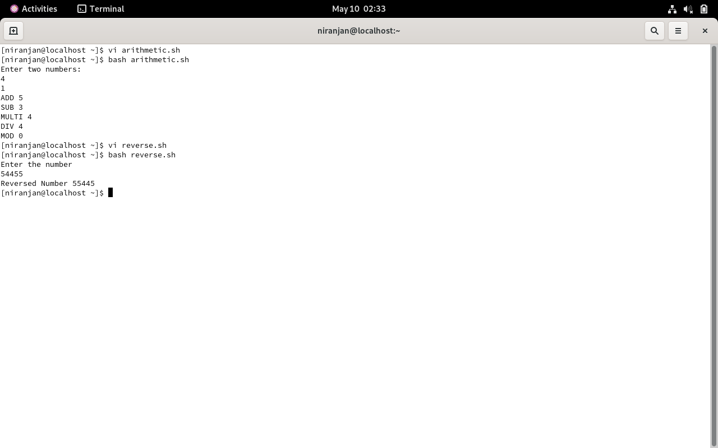

Result
The shell script was successfully created and executed. The experiment demonstrated how commands can be automated using shell scripting, and the output was verified correctly.

